**UNIT TEST DOCUMENT**

**COVER PAGE**

|  |  |  |  |  |
| --- | --- | --- | --- | --- |
| **Document Name:** | | MUSCA-ARITHMO | | |
| **Document ID:** | | MUSCA-ARITHMO-TC-<1> | | |
| **Data Classification** | | Internal | | |
| Note: After the form gets filled by the user the data classification Label should be updated to "Confidential" | | | | |
| **Modification History** | | | | |
| *(Kindly remove this table as this is the modification history of the template)* | | | | |
| **Purpose of the Template** | |  | | |
| **Date** | **Author** | | **Change Description** | **Version** |
| 31-May-2021 | Kamali Selvaraj | | SIMPLETAX – WHICH USER TEXT UPDATE | 0.1 |

**Test Case 1:**

|  |  |  |
| --- | --- | --- |
| **Test Case Description** | |  | | --- | | Checking text update(banner1) | |
| **Unit / Module or Location Description** | |  | | --- | | Edit page | |
| **Test Case Steps** | 1. Login the application 2. Go to the edit page |
| **Test Results** | |  | | --- | | The text will be updated in Which? Membership validation banner | |
| **Additional Comments** |  |

**Test Case 1 (Screenshot):**

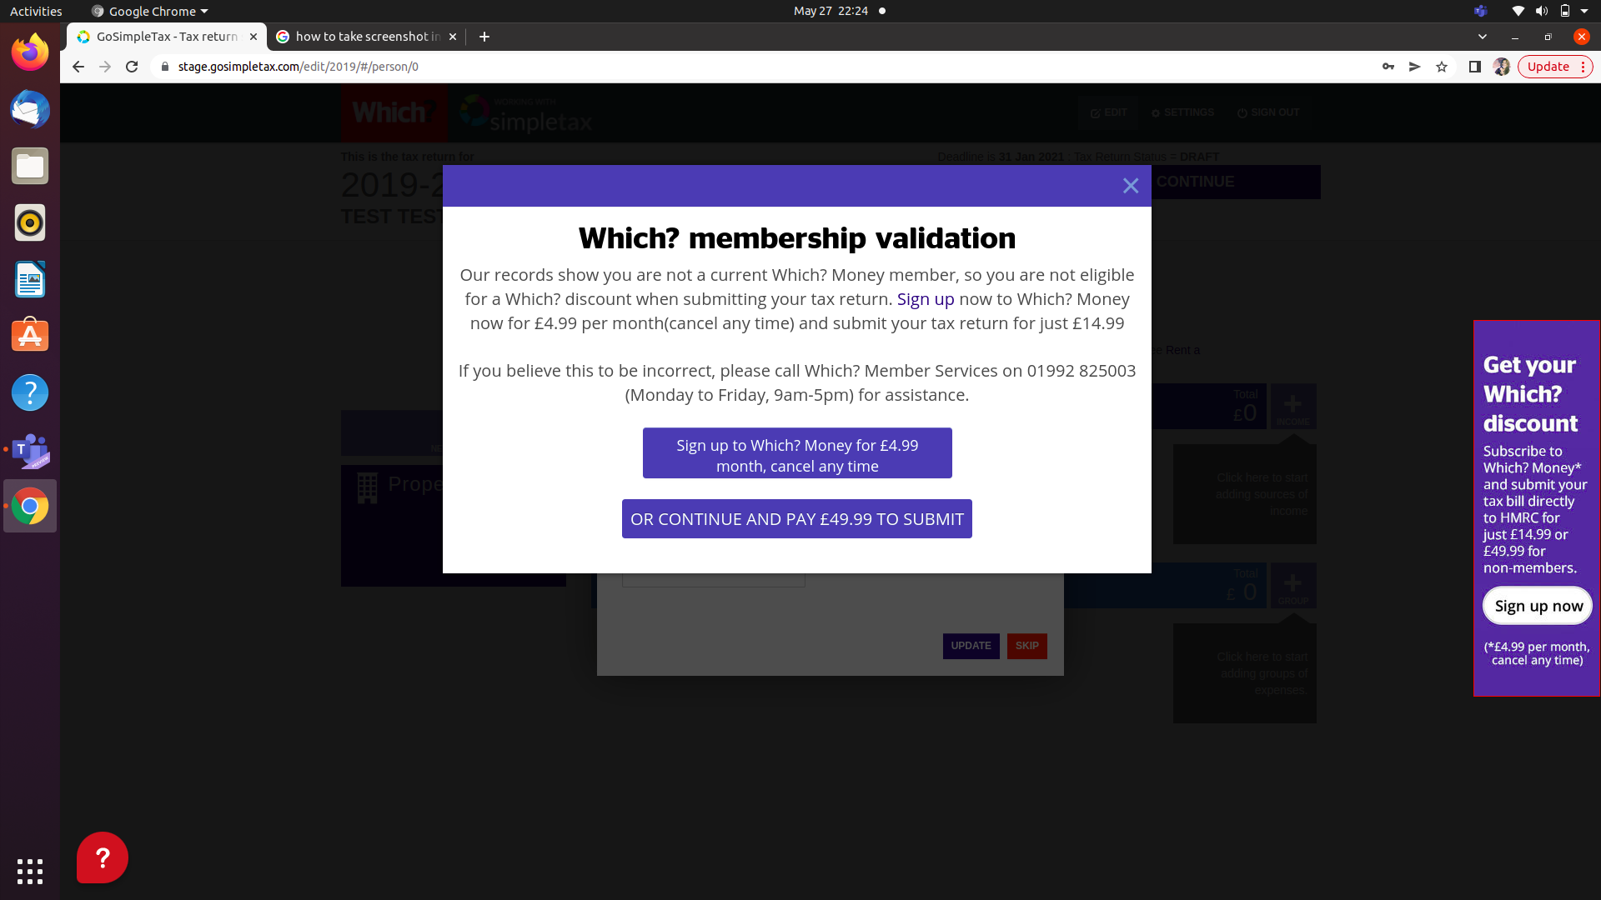

**Test Case 2:**

|  |  |
| --- | --- |
| **Test Case Description** | Checking text update(banner 2) |
| **Unit / Module or Location Description** | Edit page |
| **Test Case Steps** | 1. Login the application 2. Go to the edit page 3. Click on the side banner |
| **Test Results** | The text will be updated on Get your Which? Discount banner |
| **Additional Comments** |  |

**Test Case 2 (Screenshot):**

